

**Exercise: Calibrate abatement model and increase carbon tax**

EU TSI Project 101195159 GreenREFORM EU

# Create container and read clean parameter and set

A: Initialize a container and write a gdx containing a single set called "my_first_set" with elements "one", "two", "three" (populate manually)

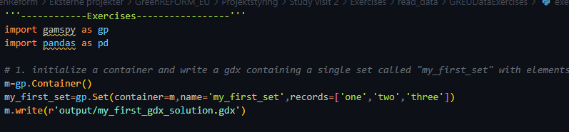

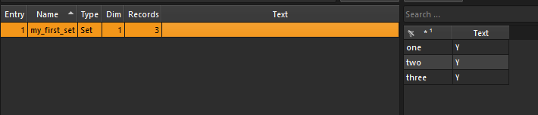

B: Read the excel file data/some_parameter_ex1.xlsx and create sets and a parameter in a container

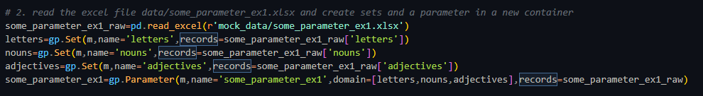

# Altering sets and parametres

A: Read the excel file data/some_parameter_ex2.xlsx and create a parameter in the same container as in exercise 2 adding missing elements to sets as needed

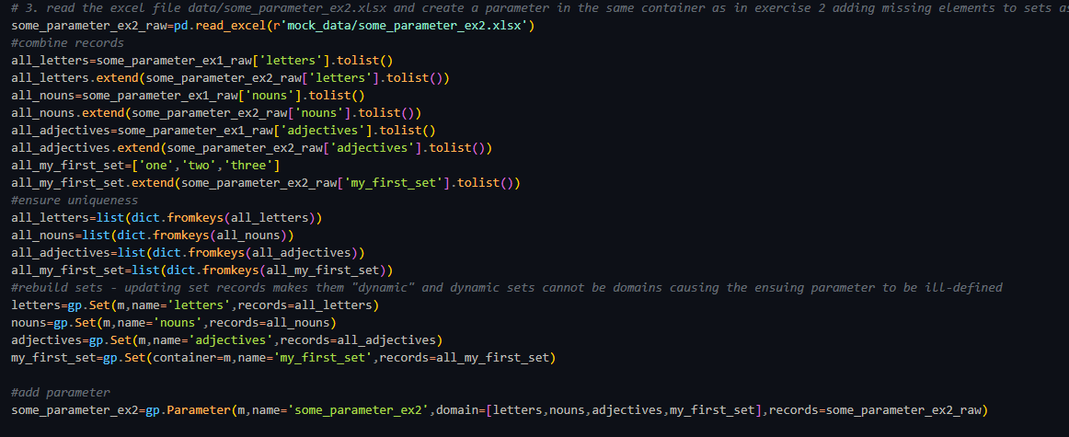

B: Create the set "colors" as a subset of adjectives containing only the color-adjectives and add it to the container

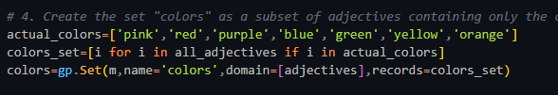

C: Read some_parameter_ex3.xlsx and create a parameter in the same container as in exercise 1-4 dropping entries containing NaN as needed

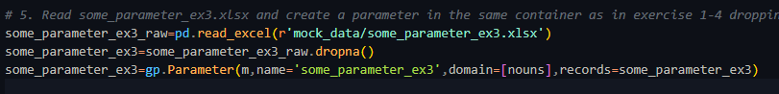

# Using metadata and export

A: Read some_parameter_ex4.xlsx and create a parameter in the same container as in exercise 1-5 renaming elements according to mock_metadata.xlsx as needed

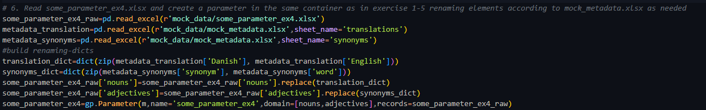

B: export gdx and compare to "solutions.gdx"



DO NOT OVERWRITE SOLUTIONS…

